Week 1

This week we had couple of tasks which included how to install and integrate nodejs with vscode. Further learnt about how to use prompt and parseint built in functions. Next did some basic coding which included: printing couple of statements, introduction of if-else statements, a little bit of error handling. At last we did a little project of our own which included basic mathematical operations.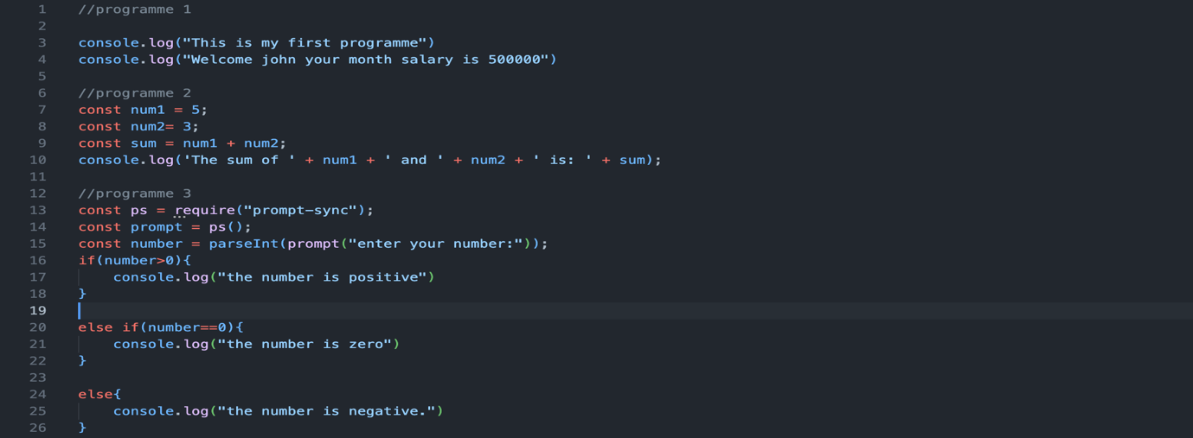

Week 2

This week was an interesting one as we were introduced to MongoDB. We started this week’s tutorial with installing mongodb compass on our machines and learning how to create a database and a collection of data within that database. Further we learned how to manipulate the data in that collection by using various functions like add, update, delete and aggregate. Then we learned how to match and group the data to filter out the results based on the demands of a user.

Week 3